Brainstorm

& idea prioritization

Use this template in your own brainstorming sessions so your team can unleash their imagination and start shaping concepts even if you're not sitting in the same room.

## Before you collaborate

#### A little bit of preparation goes a long way with this session. Here’s what you need to do to get going.

**10 minutes**

##### Team gathering

Define who should participate in the session and send an invite. Share relevant information or pre-work ahead.

##### Set the goal

Think about the problem you'll be focusing on solving in the brainstorming session.

##### Learn how to use the facilitation tools

Use the Facilitation Superpowers to run a happy and

**1**

## Define your problem statement

#### What problem are you trying to solve? Frame your problem as a How Might We statement. This will be the focus of your brainstorm.

**5 minutes**

**PROBLEM**

How to analyze and predict the quality of water in an efcient way? How to test it?

**2**

## Brainstorm

#### Write down any ideas that come to mind that address your problem statement.

**10 minutes**

**PAVITHRA K**

**SARAVANAN TG3**

## Group ideas

#### Take turns sharing your ideas while clustering similar or related notes as you go. Once all sticky notes have been grouped, give each cluster a sentence-like label. If a cluster is bigger than six sticky notes, try and see if you and break it up into smaller sub-groups.

**20 minutes**

**Chemical properties Cleanliness and Biological Aspects Physical Properties of water**

**4**

## Prioritize

#### Your team should all be on the same page about what's important moving forward. Place your ideas on this grid to determine which ideas are important and which are feasible.

**20 minutes**

**Turbidity**

## After you collaborate

You can export the mural as an image or pdf to share with members of your company who might find it helpful.

**Quick add-ons**

##### Share the mural

**Share a view link** to the mural with stakeholders to keep them in the loop about the outcomes of the session.

##### Export the mural

Export a copy of the mural as a PNG or PDF to attach to emails, include in slides, or save in your drive.

**Deep neural network**

**10 minutes** to prepare

**1 hour** to collaborate

**2-8 people** recommended

productive session.

[**Open article**](https://support.mural.co/en/articles/2113740-facilitation-superpowers)

**Temperature**

**Logistic Regression**

**Dissolved Oxygen Concentration**

### Key rules of brainstorming

To run an smooth and productive session

**Water Colour**

**Linear**

**Algae content**

**Artifcial neural Network**

**Chloride Ions**

**Minerals Present**

### Keep moving forward

##### Strategy blueprint

Define the components of a new idea or strategy.

##### [Open the template](https://app.mural.co/template/e95f612a-f72a-4772-bc48-545aaa04e0c9/984865a6-0a96-4472-a48d-47639307b3ca)

**Customer experience journey map**

Stay in topic.

Defer judgment.

Encourage wild ideas.

Listen to others.

### Fluid Properties

**Classifcation**

### Clustering

**Importance**

If each of these

# Presence of Radio

**Regression**

Understand customer needs, motivations, and obstacles for an experience.

##### [Open the template](https://app.mural.co/template/b7114010-3a67-4d63-a51d-6f2cedc9633f/c1b465ab-57af-4624-8faf-ebb312edc0eb)

Go for volume. If possible, be visual.

**SABAREESWARAN C**

**DIWAKAR S**

# K Methods K Means

tasks could get done without any difficulty or cost, which would have the most positive impact?

# Active Substance

##### Strengths, weaknesses, opportunities & threats

**Hardness**

Identify strengths, weaknesses, opportunities, and threats (SWOT) to develop a plan.

|  |  |
| --- | --- |
|  |  |
|  |  |

[**Open the template**](https://app.mural.co/template/6a062671-89ee-4b76-9409-2603d8b098be/ca270343-1d54-4952-9d8c-fbc303ffd0f2)

# K Nearest Neighbours

[**Share template feedback**](https://muralco.typeform.com/to/CiqaHVat?typeform-source=app.mural.co)

**BIO**

**Indicators Present**

**Viscosity**

**Water Odour**

**Neural network Regression**

**f**

**Foaming Property**

**K Nearest Neighbours**

**Salinity**

[**Share template feedback**](https://muralco.typeform.com/to/CiqaHVat?typeform-source=app.mural.co)

### Feasibility

Regardless of their importance, which tasks are more feasible than others? (Cost, time, effort, complexity, etc.)

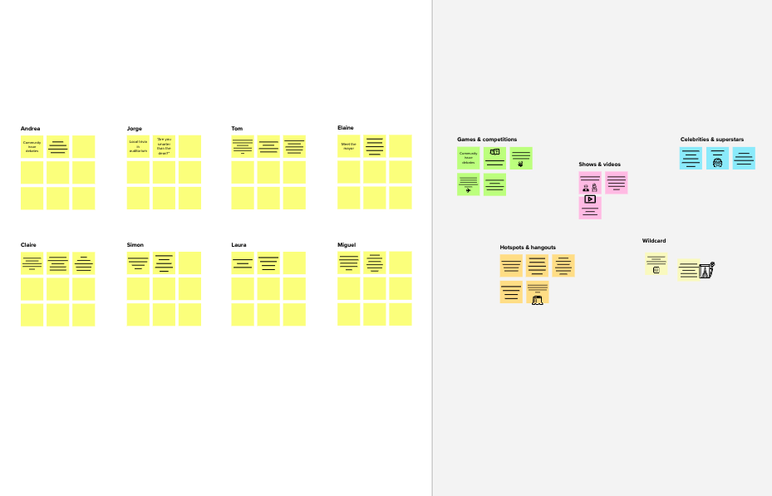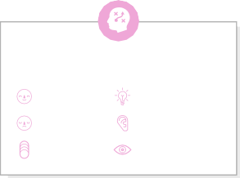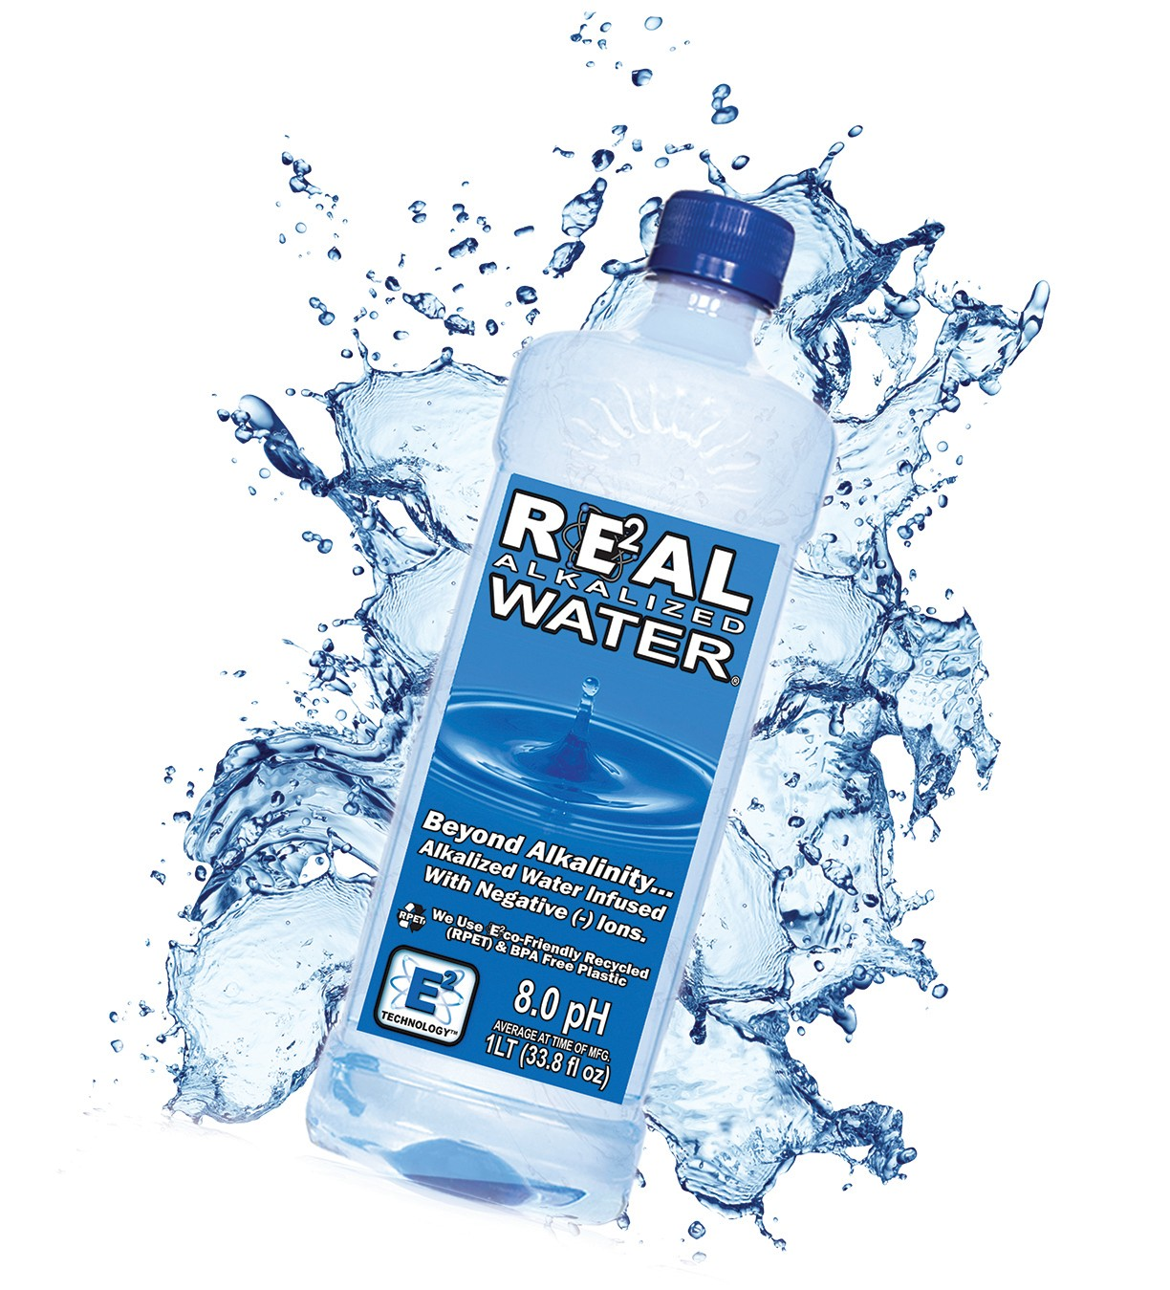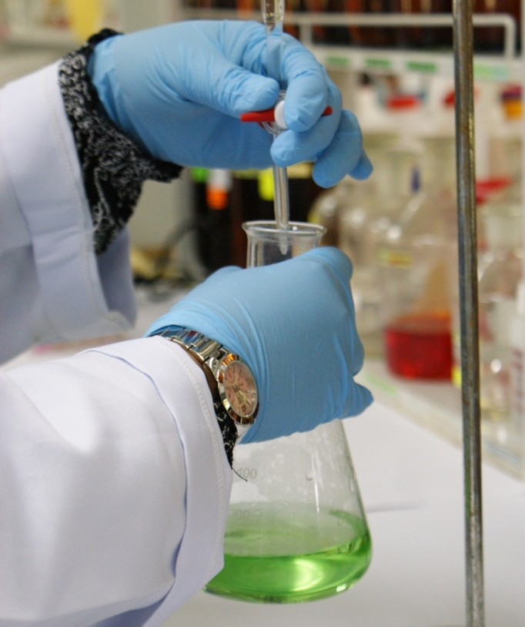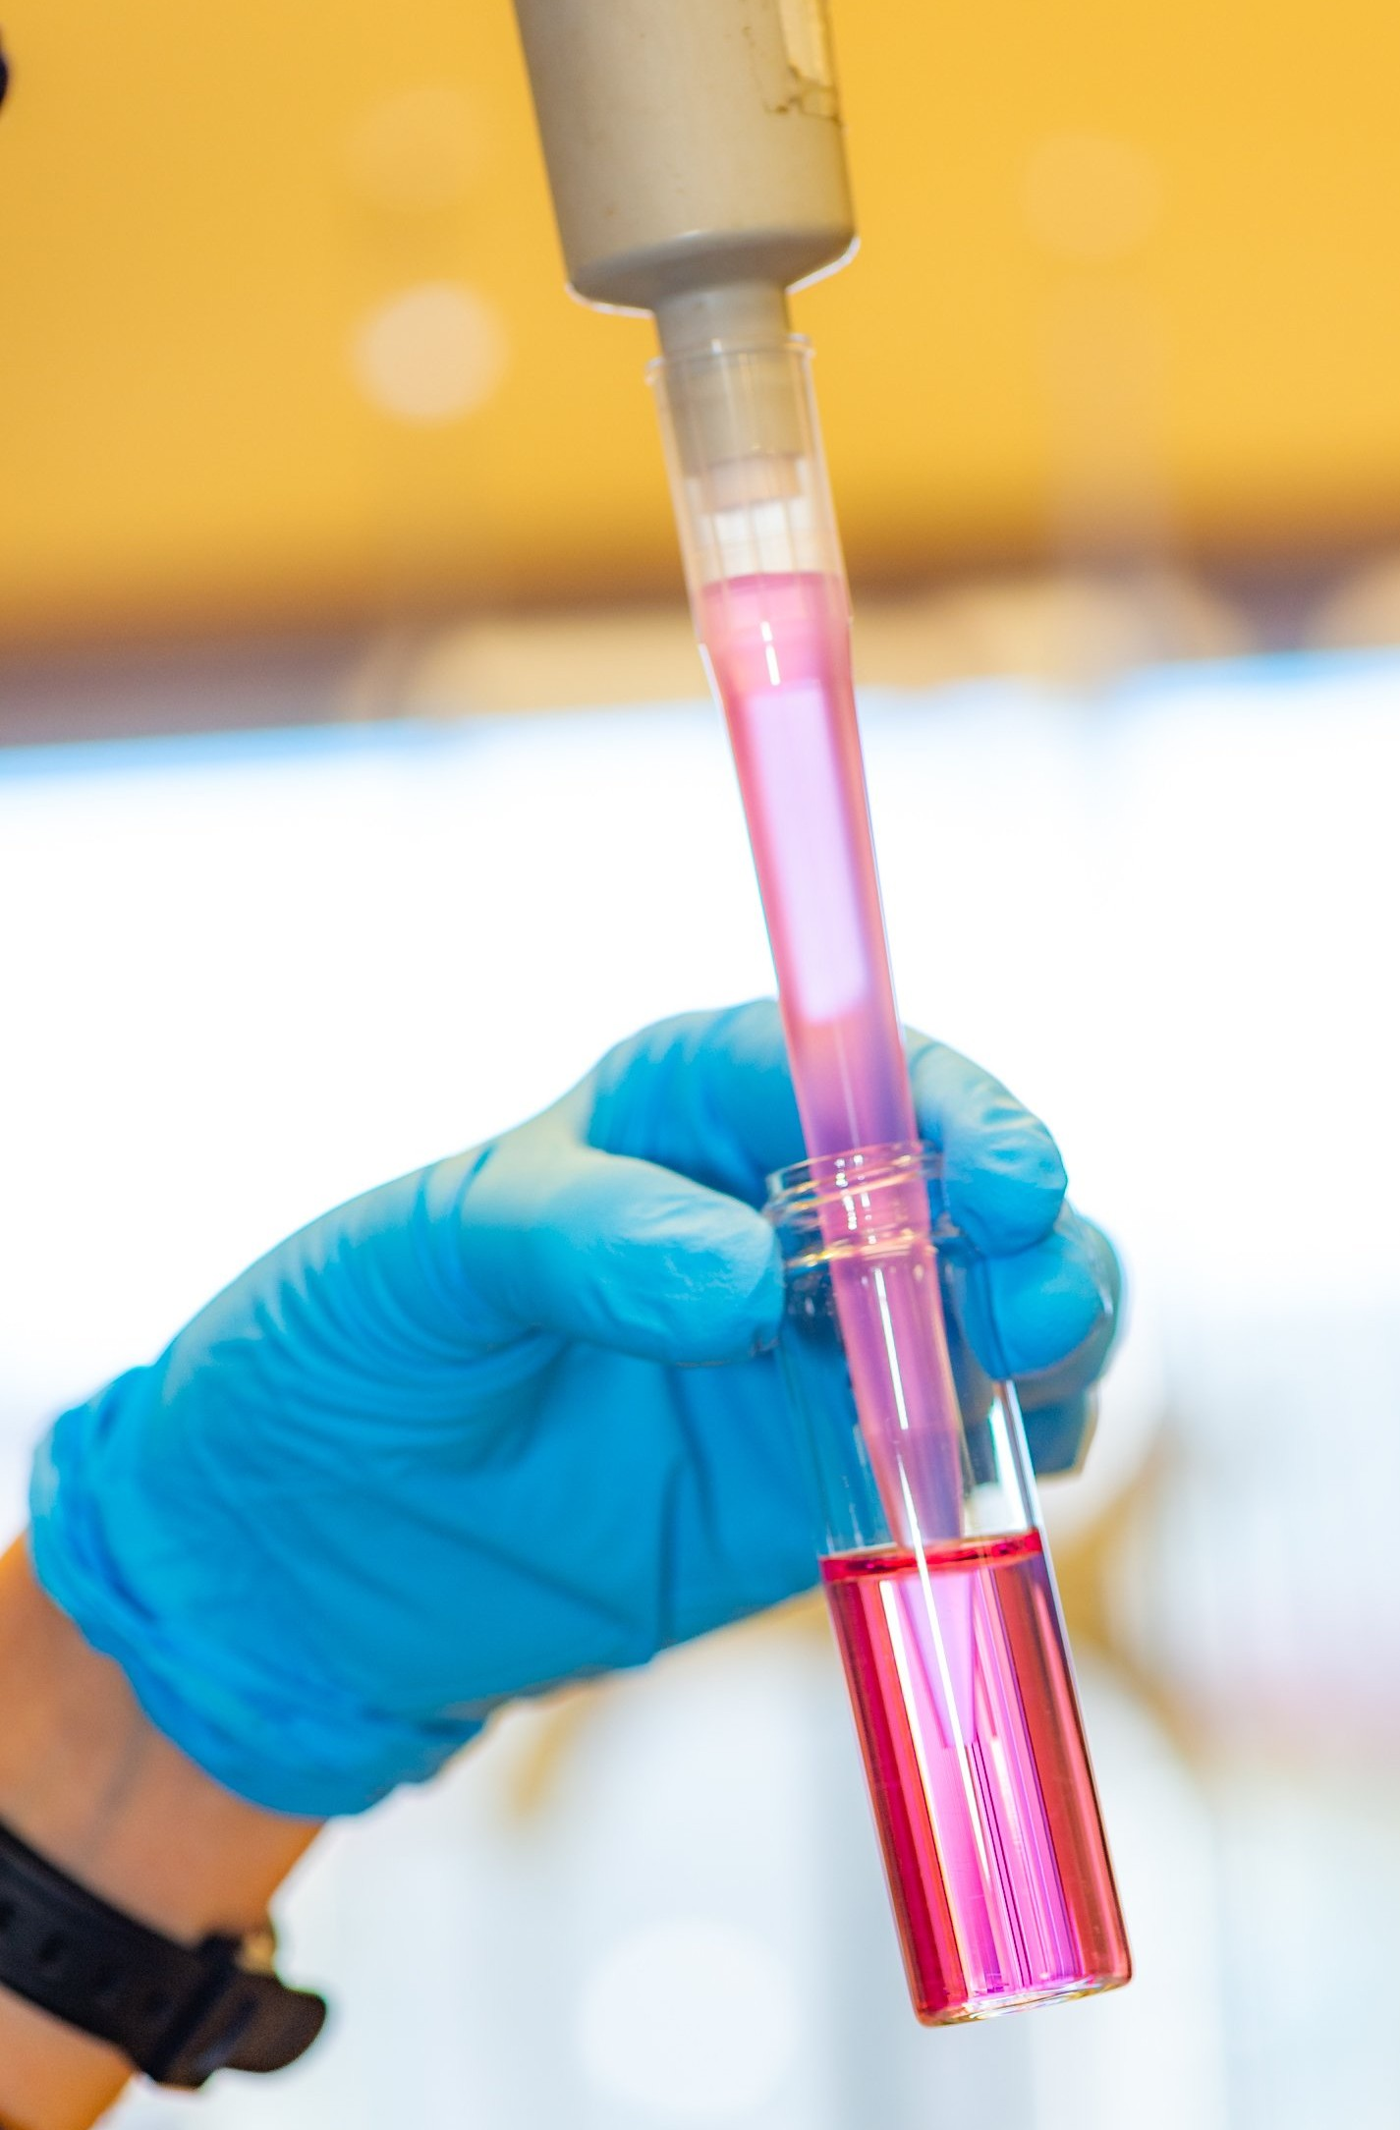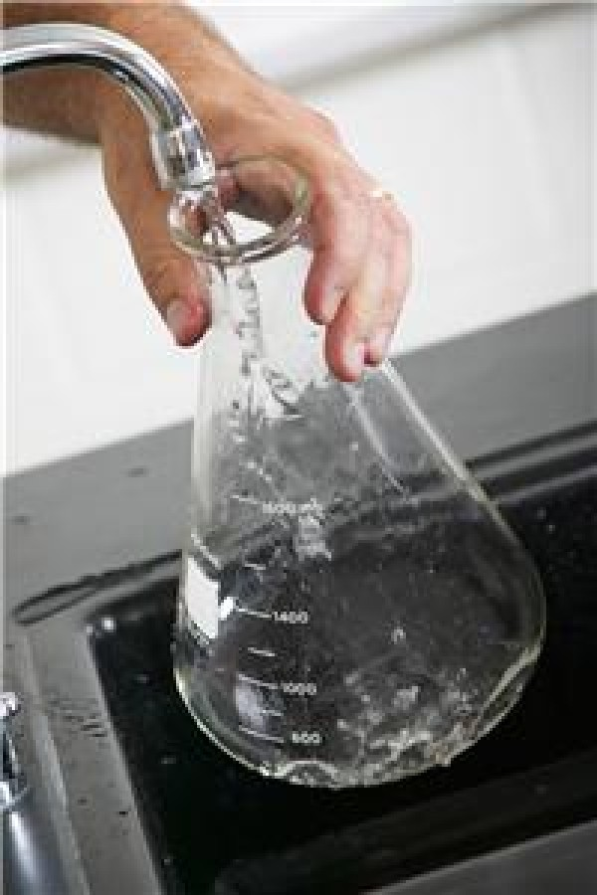

**Water Taste**

**Water Colour**

**Temperature**

**Water Odour**

**K Methods**

**Water Odour**

**Turbidity**

**Chloride Ions**

**Logistic Regression**

**Decision Tree**

**Electrical**

**Algae**

**Conductivity Content**

**Presence**

**Hardness of Radio**

**Active**

**Substance**

**Dissolved Oxygen Concentration**

**Chloride Ions**

**Minerals Present**

**BIO**

**Indicators Present**

**Algae content**

**Turbidity**

**Aritificial Neural Network**

**Water Colour**

**Minerals Present**

**Hardness**

**Naive Bayes**

**Polynomial Regression**

**Viscosity**

**BIO**

**Indicators Present**

**Viscosity**

**Foaming Property**

**Turbidity**

**Salinity**

**SVM**

**Naive Bayes**

**Decision Tree**

**Logistic Regression**

**Deep Neural Water Taste**

**Network**

**Linear Regression**

**pH level o Water**

**K means**

**Redox Potential**

**Foaming Environment**

**Property**

**Presence of Radio Active Substance**

**Temperature**

**Water Level**

**Salinity**

**SVM**

**Water source**

**Boiling Point**

**Dissolved Oxygen Concentration**

**Linear**

**Polynomial**

**Regression Regression**

**Deep neural network**

**Artifcial neural Network**

**Template**

**Need some inspiration?**

See a finished version of this template to kickstart your work.

[**Open example**](https://app.mural.co/template/e5a93b7b-49f2-48c9-afd7-a635d860eba6/93f1b98d-b2d2-4695-8e85-7e9c0d2fd9b9)